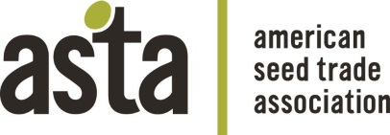 | 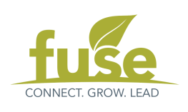

ASTA’S FUSE Campus Connections Program Application

Personal Information

Name: | Gender: M / F / Prefer not to disclose
Address:

City, State, Zip:

Main Phone: | Alternate Phone:
Email:

Date of Birth:

Academic Information

University: | Department:
Major: | Target Graduation Date:
Overall GPA:

Title of Research (if any):

Post-Graduation Plans:

Summer 2017 Internship Plans (at minimum, please include company/job title):

Please include a resume with your completed application.

Experience and Involvement

- Summarize your experiences and involvement in organizations outside of academics (i.e. community, campus, church, sports).

- List any awards or distinctions you have received.
Questions

Please limit your answers to approximately 200 words each.
- Why should you be chosen to participate in the Campus Connections Program?
- What are your expected outcomes of participating in the program?
- What can you offer the seed industry, as well as your peers, mentors, and other attendees, at ASTA’s annual convention?
- What inspired you to pursue an education and career in the seed industry?

Agreement and Signature

By submitting this application, I affirm that the facts set forth are true and complete.

Signature: _________________________________

Name (print): ______________________________ | Date: __________

Application Review Policy

All applications will be reviewed by the Connections subcommittee.

Return completed application and resume by January 27, 2017 via mail, fax, or email to:

American Seed Trade Association
ATTN: FUSE
1701 Duke Street Suite 275
Alexandria, VA 22314
fuse@betterseed.org
F: (703) 837-9365

Please direct any questions to fuse@betterseed.org and
a member of the Connections Committee will follow up with you.

